**I230549**

**LAB 6**

Q1) 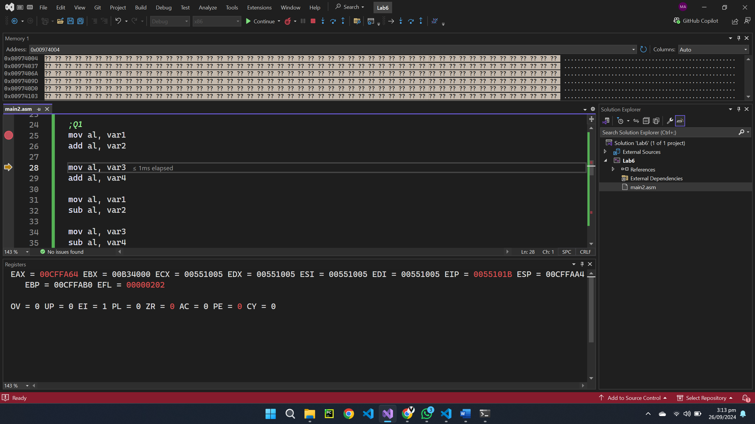

Q2) 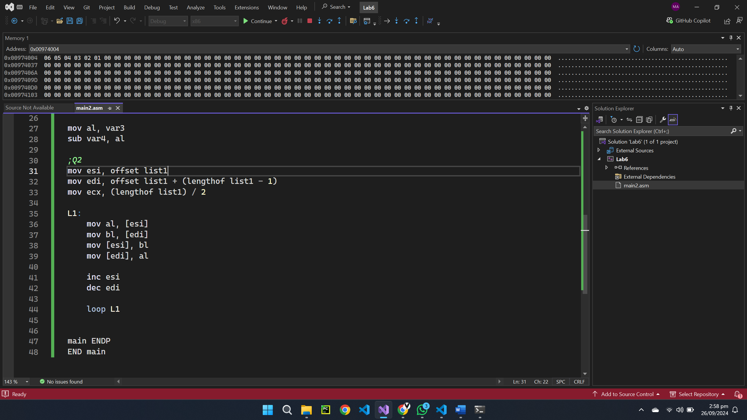

Q3) 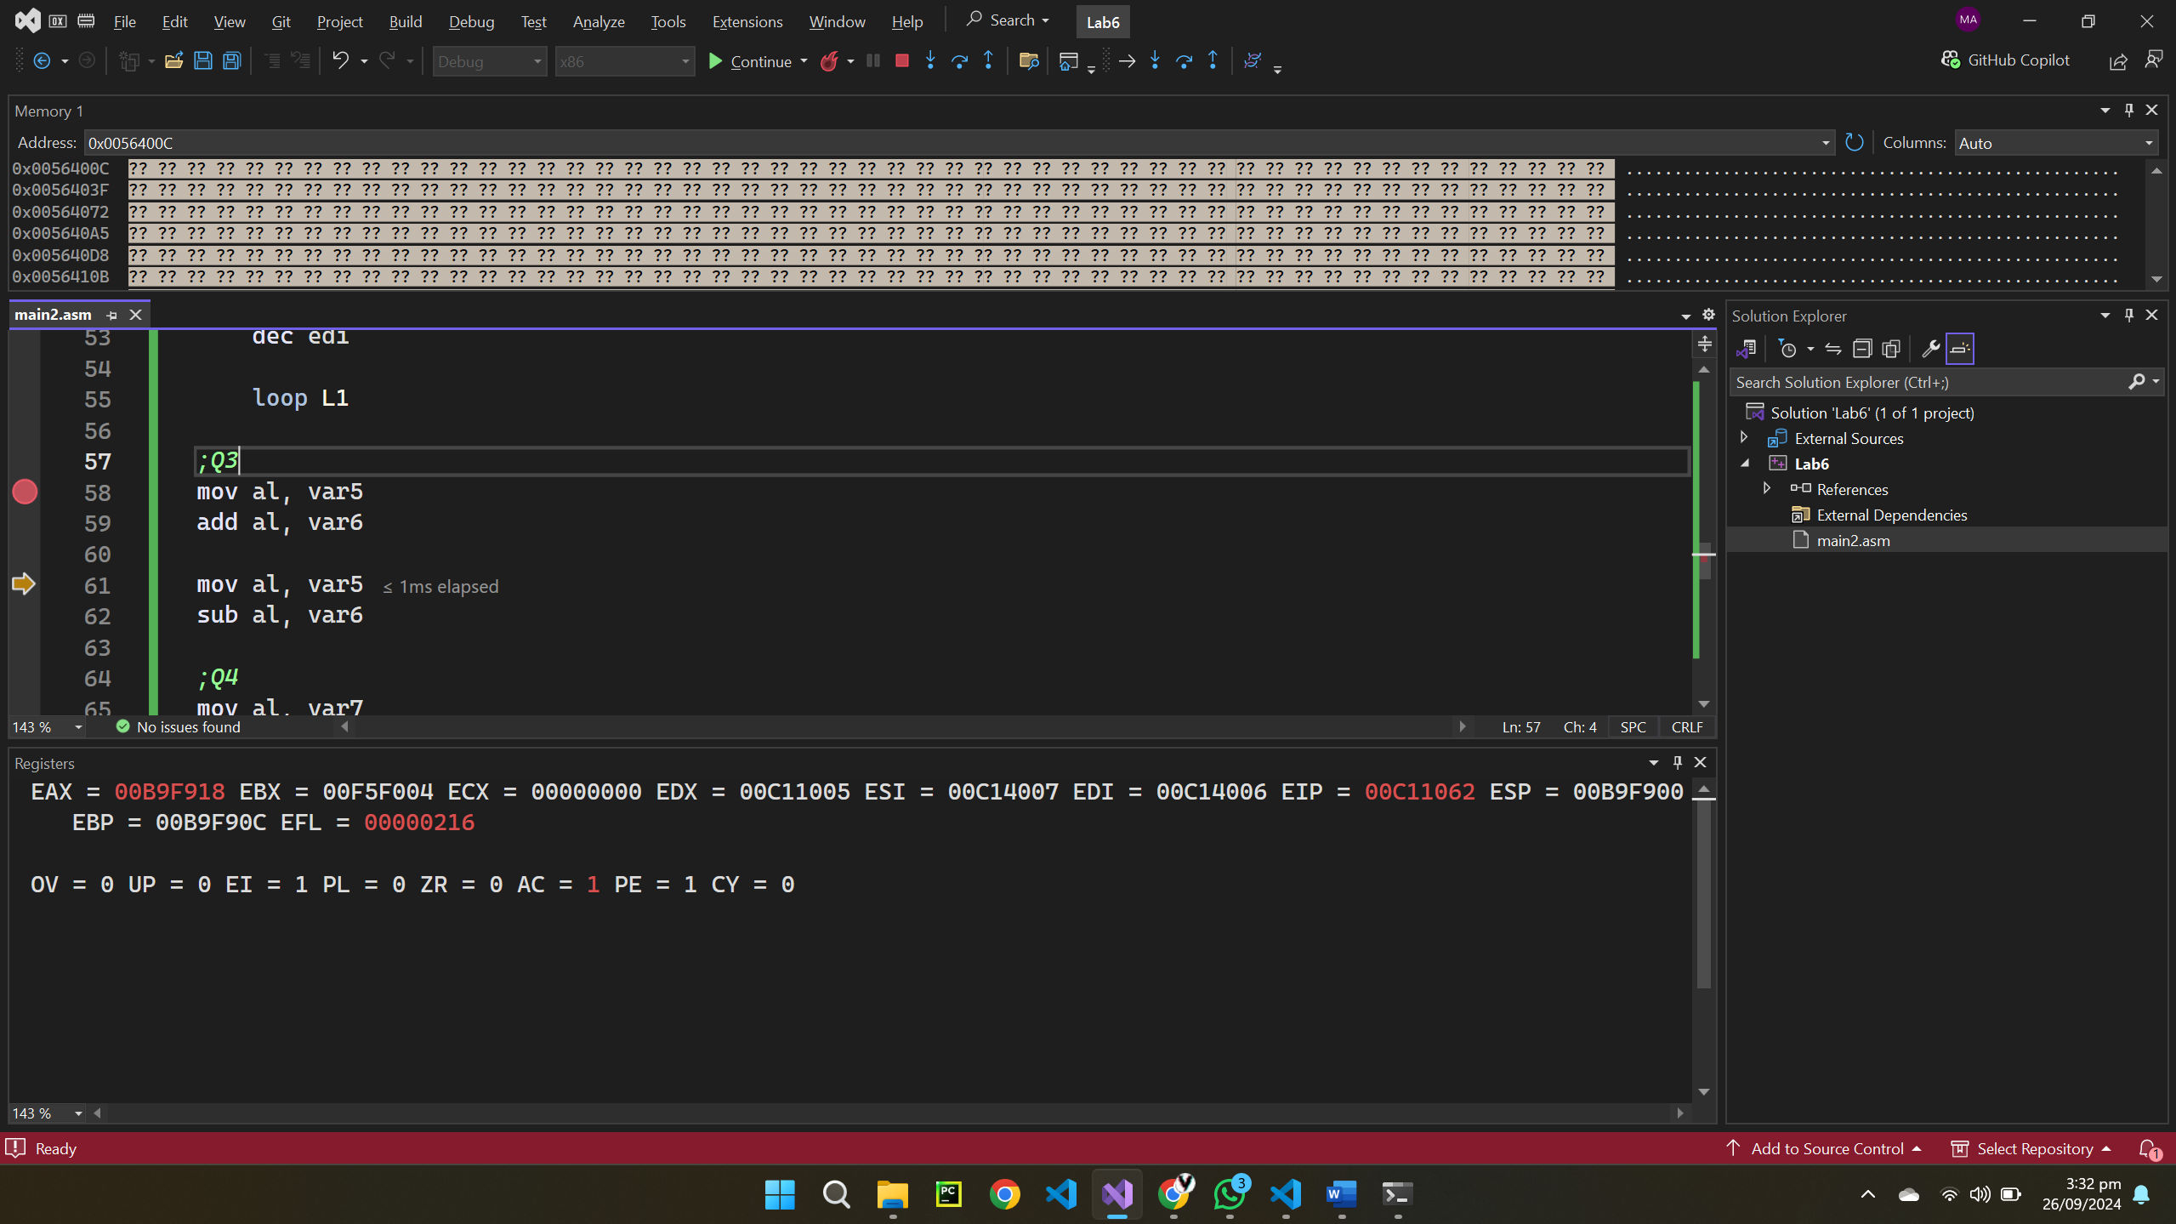

Sign flag: Set because a larger number is subtracted from a smaller one

Parity flag: reset as the subtracted number has an odd number of 1’s

Carry flag: The subtraction generated a carry

Sign flag: MSB is 0

Auxiliary flag: Reset as there was no carry from the first nibble

Parity flag: The result has an even number of 1’s

